**Game Grid**

Implement a ReactJS casino grid app

**Requirements**

* Use React with JS or TS
* The app should have two views
  + **Grid View** – shows a list of games with title and thumbnail in a grid layout. First game in the collection should be shown as big one. Upon clicking on any of the items, the “Active Item View” is shown.

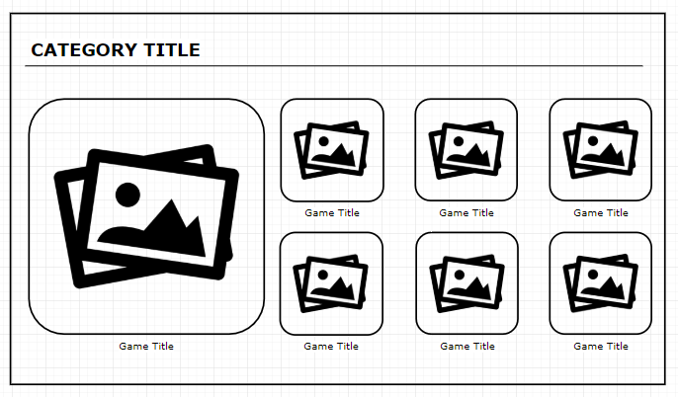

* + **Active Item View** – shows thumbnail, title and description of the game. A “playbox” is shown in the center, which will only include a loading animation (game loading simulation)

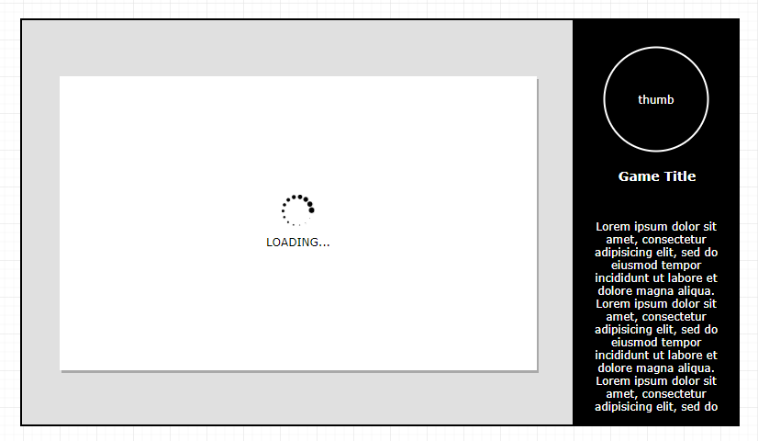

* Design – design and color is by choice. Colors in the screenshot are just an example
* Data – please use the following as mock data to fill the grid - <https://drive.google.com/file/d/1DUDNuGoBX1soI0jHg2HCUnyeN0JKsaRs>
* CSS libraries are allowed